Thank You
Making space in your pressured working lives to accommodate QUB medical students is hugely appreciated. In Spring 2019 we visited 7 practices around NI who have all been involved in student teaching. For one practice it was their first year as a QUB teaching practice, and for others it had been decades. GPs and practice managers shared their personal experience of how much they enjoyed this role. We hope this video will encourage new practices to take up the opportunity.
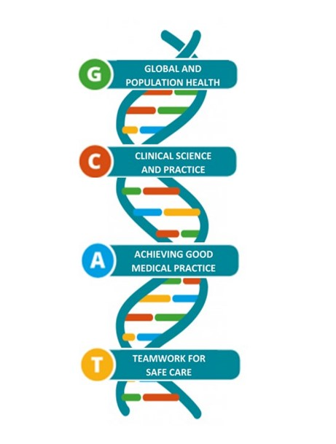
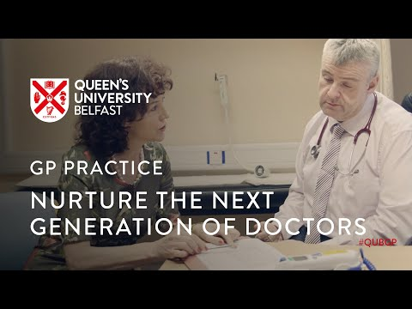
Click on the link below to view
If your practice currently takes one 5th year student, have you thought about taking two together? The students themselves appreciate it and the workload is not doubled, but the remuneration is.
If your practice is in greater Belfast, there are more opportunities to take small groups of students in 1st or 2nd year. To find out more email
gpadmin@qub.ac.uk

Changing GP faces at QUBGP
2019 has brought some new faces to our team. Dr Louise Sands and Dr Jim McMullan are both working closely with practices as we prepare for the changes that the new curriculum will bring.
We were very sad to bid farewell to Dr Kieran McGlade who retired recently. Kieran had many significant roles over the years in the medical school but GP tutors will know him best for his sterling work on communication skills and the family attachment scheme. We bid him a long and happy retirement.
All the GPs in our team continue to work in clinical practice and are aware of the challenges in terms of workload, manpower and premises.
From L-R
Dr Jenny Johnston, Dr Nigel Hart, Cathleen Agnew (QUBGP admin), Dr Neil Heron, Dr Helen Reid, Dr Louise Sands, Dr Carla Devlin, Dr Finbar McGrady,Dr Grainne Kearney, Dr Kieran McGlade (retired Summer 2019), Dr Jim McMullan.
Big changes for the medical school with C25 curriculum
Over the past 5 years we have been incrementally increasing the amount of General Practice in the Curriculum. Several years ago some of you participated in a pilot week in the post-finals ‘Assistantship’ and this was so successful that all students have 1 week in GP as part of this module. 2017-18 saw the successful placement of 260 final year students for a 2 week GP attachment and in 2018-19 we saw an extension of the Family Attachment scheme into second year. In 2019-20 the final year attachment is increasing from 2 to 4 weeks.
The new C25 curriculum will be introduced from autumn 2020 with the first graduates completing in 2025. The diagram above shows the 4 themes that provide the framework for the curriculum. 25% of the course will be delivered in primary care.
Have you seen our new website?
Our QUBGP website has been a “work in progress.” You will now find lots of information and resources that we hope are useful. We will continue to add to it and would value your feedback as to what information you want to see there.
www.med.qub.ac.uk/wp-gp
You will find many resources via QUB Medical Education portal. If you have not used it yet, then click on the link below to register
www.med.qub.ac.uk/portal/Account/Register

We want to hear from you
We are striving to improve our communication with practices. We know that staff change as do preferred email addresses. Thank you to all the practices who have completed the short practice survey (< 5mins). If you have not completed it, then you can access it at the link below.
https://www.surveymonkey.co.uk/r/JXG6W2F
We also want to hear what you would like included in GP tutor CPD sessions and in written resource materials for teaching. We plan to send out a very short survey to each GP tutor to give you the chance to tell us that.

Update from our QUBGP Leads

Family attachment – Dr Grainne Kearney
This is now called “Introduction to Family Medicine” (IFM). It runs for the first two years of the undergraduate curriculum and comprises the “Family Attachment Scheme” (FAS) in first year (part of the curriculum for many years) and the “General Practice Experience” (GPE) course in second year (launched in 2018/19).
The FAS receives enthusiastic feedback from the students and received particular mention during the GMC visit in 2017. The practices need to be located close enough to QUB to allow students to commute there for an afternoon session.
FAS comprises five tutorials, all of which will take place at your general practice premises. In addition, students visit patients in their own homes by mutual arrangement and in students’ own time. You should be reassured that recent research suggests that your patients are very enthusiastic about the scheme and enjoy the students’ visit.
In the second year GPE component, the students will be attending your general practice premises for 5 teaching sessions. During this time, students will be divided between various activities, some of which will take place in the practice and some which may be external to the practice (e.g. visiting a patient at home or visiting a nursing home). These activities should be designed to give students early insights into the pivotal role general practice plays in delivering care to patients.
New developments for 2019/20:
The tutor and study guides have been revised and updated based on feedback from both students and tutors.

YEAR 4 – Dr Helen Reid
Student feedback 2018/19 was incredibly positive…...
“Being out in General Practice was AMAZING. Much better than being in a hospital.”
“One of the first times I’ve felt part of the team in any aspect of medical education.”
“Absolutely fantastic placement - could not have felt more welcome or part of the team. I felt valued.”
“I thoroughly enjoyed time spent hot seating and seeing patients on my own. I feel it really helped develop my skills and confidence when consulting with patients.”
“Prior to this attachment, I had never considered GP as a career. The team have made me strongly consider a career pathway into General Practice. I cannot praise them highly enough.”
Students allocated GP towards the beginning of year 4 can feel ‘hard done by’ in that they may have no prior exposure to healthcare of children, women or mental health – for some students, the sheer breadth of our clinical work seems overwhelming. As is often the case, the main gripe from students was that their placements in GP are too short, something which will, to a large extent, improve as the C25 curriculum takes shape.

New developments for 2019/20:
· We have updated (and reduced to A5) the student logbooks, in efforts to not only save a few trees, but make the document more user-friendly.
· We are piloting student involvement in Social Prescribing initiatives across NI, offering students (with your agreement) short experiences facilitated through local Healthy Living Centres. We will be in contact with specific practices with further information including who students should contact.
· Based on student feedback (and the GMC’s updated Outcomes for Graduates), we have developed a new teaching session in the introductory week to introduce students to some of the mental health issues we often encounter, and the impacts of work on health.
While we don’t want to develop all students into GPs (we do still need some future secondary care colleagues!), we aim to make them all understand more of the healthcare world beyond hospitals.

YEAR 5 – Dr Finbar McGrady
Student feedback shows how much these students value being in General Practice…...
“Saw my own patients in my clinic morning and afternoon, found this really helpful and got the most out of this.”
“Seeing patients ourselves throughout entire placement. Excellent clinical supervisors and always getting feedback.”
“Excellent teaching throughout, great clinical exposure, constructive feedback given and made to feel part of the team.”
New developments for 2019/20:
Final year students will have an additional 2 weeks spent in General Practice. This will occur in the time leading up to their Final exams in early spring 2020. The purpose is to provide them with as much opportunity as possible for patient interaction taking histories, examining and formulating clinical management plans.

GP Assistantship – Dr Nigel Hart
Final year medical students continue to have 1 week in GP as part of the ‘Preparation for Practice’ 9 week Assistantship. This attachment did not change during 2018-19 and the students continued to value the learning that comes from carrying out the Discharge Letter audit and the Patient Journey activity. The Cluster meetings which take place on the Friday of the GP Assistantship are very well received and we have no immediate plans to change the now tried and tested format.

ECHO
ECHO (Extension for Community Healthcare Outcomes) utilises webcam technology to bring people together using Zoom (a skype-like platform) to discuss clinical cases. We ran a very successful pilot with 4th year students in 2018-19 and the plan is to roll out the use of ECHO in 2019-20 for all 4th and 5th year students.

