The breakout room feature needs to be on before scheduling meetings.
If breakout rooms are turned on, the feature will be available for future sessions.
- On the left hand side of My Account, click Settings.
- Scroll down.
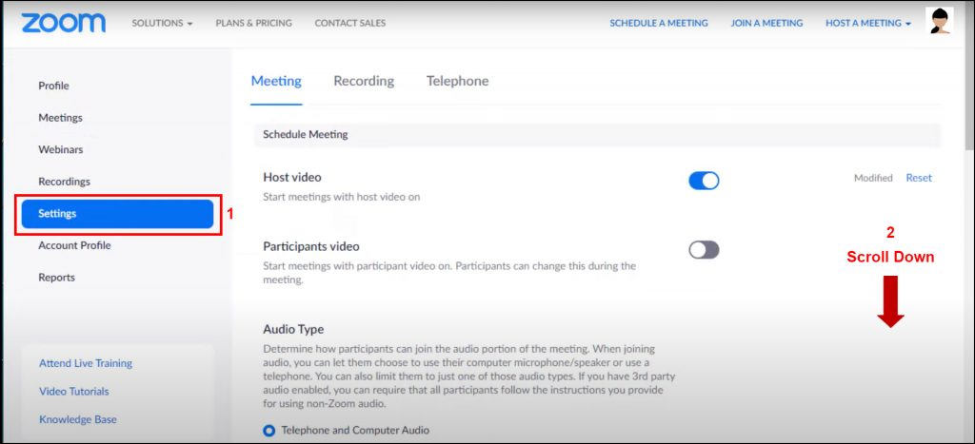
Zoom – Settings
In the Advanced section, turn Breakout Room on. This is in the General settings.
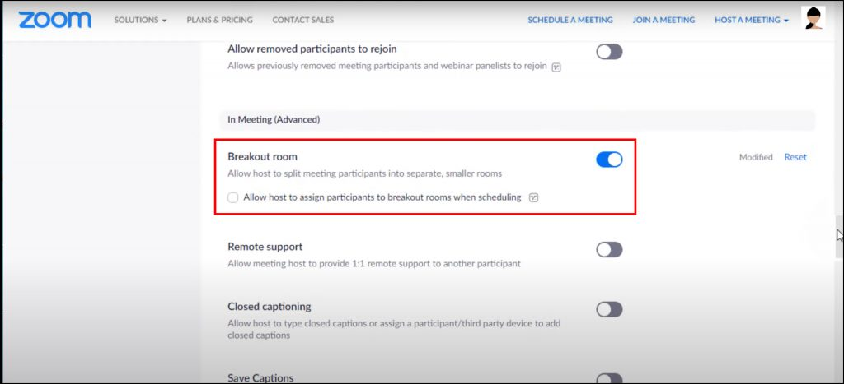
Zoom – Advanced settings
At the top of the screen, click Schedule a Meeting.
Zoom – Schedule a meeting

You can Save the meeting (the Save button is at the bottom of screen). Scroll up and click Start this Meeting.
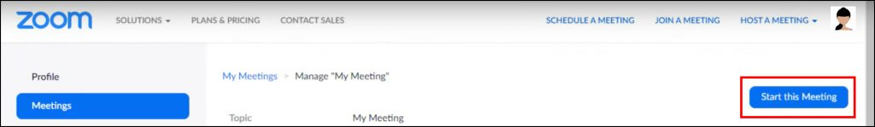
Zoom – Start this meeting

Using Breakout Rooms
Click the Breakout Rooms icon.
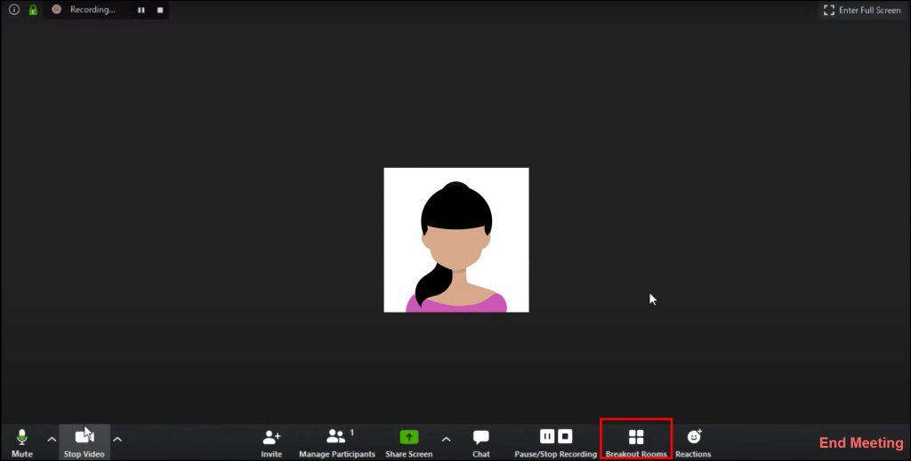
Zoom – Breakout rooms icon
A dialogue box will show how many participants are in the meeting. The host can decide how many rooms are needed. The participants can be automatically or manually assigned to rooms or moved between room, depending on needs.
Once this is set up, click Create Rooms.
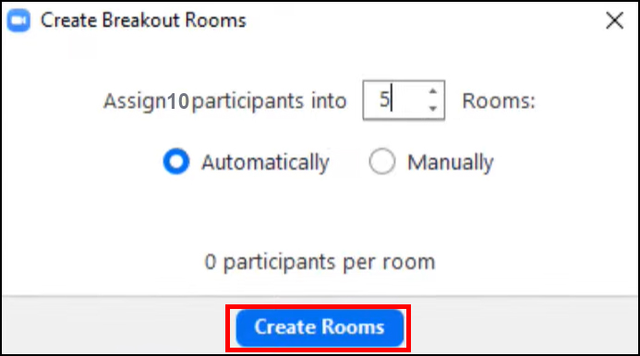
Zoom – Create breakout rooms

The next dialogue box is to open the Breakout Rooms – Not Started.
This shows the number of breakout rooms available. As host, you can see which students are in which rooms.
The participants cannot enter these rooms until the Open All Rooms option is clicked.
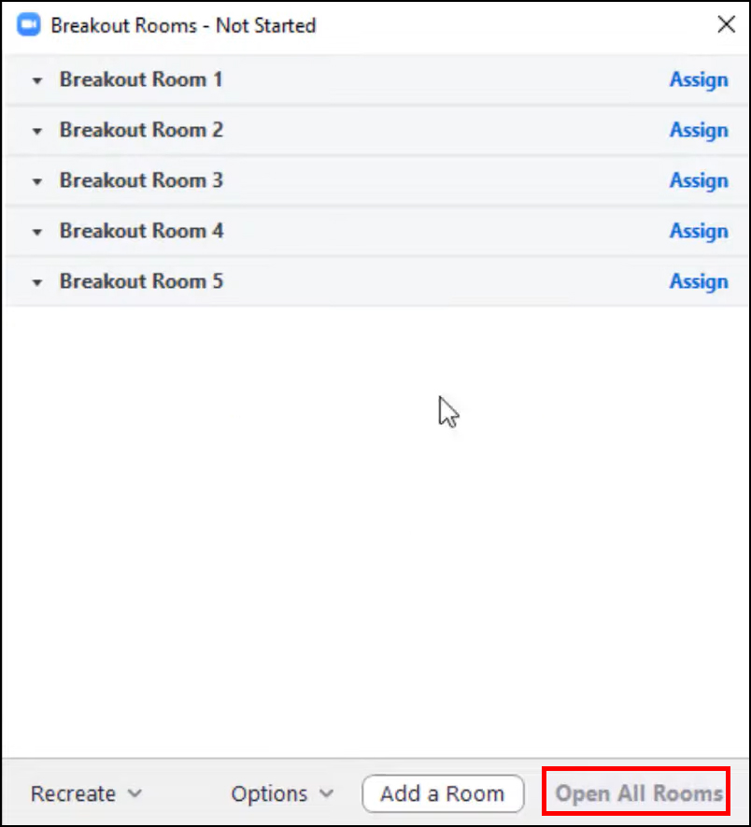
Zoom – Breakout rooms – not started

Some important settings
In the Options button of the Breakout Rooms dialogue box, there are some important options for considersation.
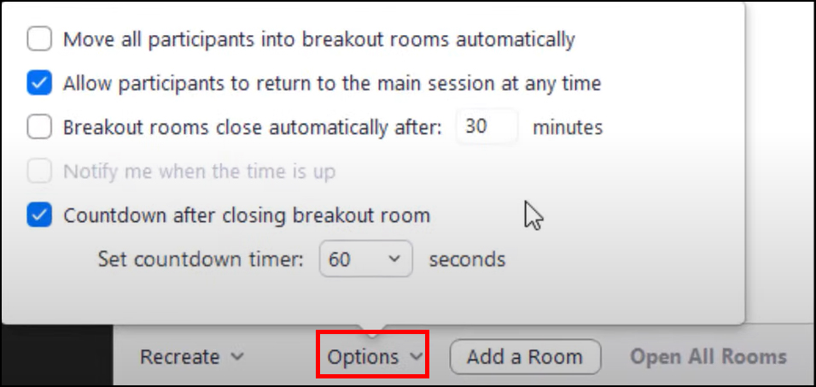
Zoom – Breakout room options
- Move all Participants to breakout rooms automatically.
It may be that students need to work in tutorial groups or they have been assigned to particular subgroups you manually set up. If this is the case, do not select this option.
- It’s important to select Allow participants to return to the main session at any time (don’t forced participants to stay in a space, its the equivalent of locking the door).
- Time-limits can be set for breakout rooms, i.e., 5 minutes. At that point, the room closes and participants enter the main room.
- The final option is a Countdown. This gives participants time to finish up tasks. This allows discussions to finish and refocuses students.

Broadcasting Messages
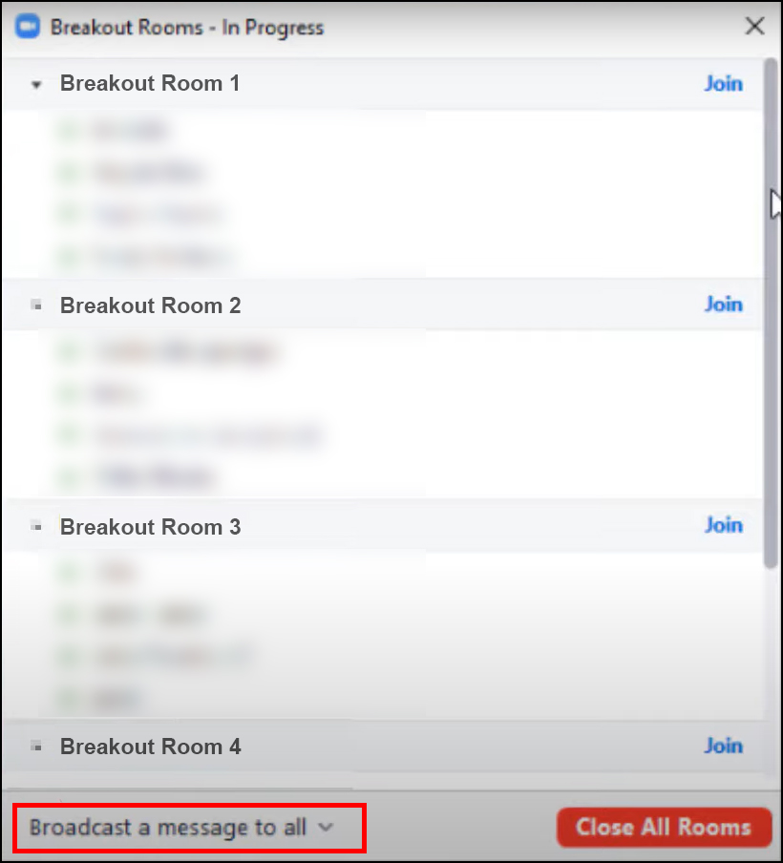
Zoom – Breakout rooms in progress
- The host can broadcast messages to all rooms by clicking Broadcast a Message to All.
This could be the topic for discussion. There are other options available should you only want to target one group.
- Hosts can join any room by clicking the Join button.
This makes the host a temporary room member and allows the host to observe or direct discussions. For the host to leave, click the Leave button beside the room.
- All rooms will close by clicking the Close All Rooms button at the bottom of the dialogue box.
This sets the counter and gives students time to wrap-up and refocus.

Moving students to other rooms can be good exercise. By rotating one student from each group, to another, students can report back on their task. This increases engagement opportunities.
To move students between groups, roll over a student name and a Move To option will appear.
Breakout rooms can be used multiple times in the same meeting. This depends on whether you want the same student groupings, or if you want to reassign students randomly.
Reassigning students randomly to breakout rooms
Click on Breakout Rooms. At the bottom of the dialogue box is a Recreate button. This resets all the breakout rooms and reassigns students randomly. This is useful to ensure students are in mixed groups per task. Click Open all Rooms.
Reassigning the same students to breakout rooms
If students need to be in the same tutorial groups, skip the recreate step and just click Open all Rooms.

Screen Share Options
When students are using breakout rooms, they will need permission to screen share. For example, students may need to discuss their slides in a breakout room.
- Beside the Screen Share icon (at the bottom of your Zoom screen), click the up-arrow.
- Go to Advanced Screen Share options.
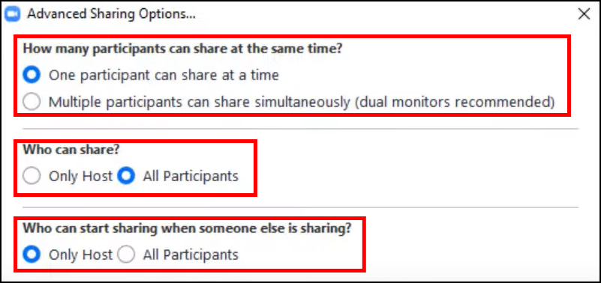
Zoom – Advanced sharing options
- In the first section, How Many Participants Can Share at the Same Time, choose One Participant can share at a time.
- In section two, Who Can Share, choose All Participants.
This gives students the capability of sharing screens in breakout rooms so slides / images / video / whiteboard can be used and/or discussed.
- Importantly, in section three: Who Can Start Sharing When Someone Else is Sharing, Only Host should be selected.

Common problems of breakout rooms
Any content generated by students within a breakout room cannot be automatically shared in the main room.
There are no features currently allowing content be shared between breakout rooms the main room. Why is this? Breakout rooms have the same features but they are separate rooms.
Imagine this as a physical space. You have a large teaching room. This room has a whiteboard which anyone can use. The breakout room also have whiteboards.
When students are working on those boards and leave the room, the board stays behind. This is the same in Zoom. How can students share their content with the main room?
Someone in the group needs to capture it on their device. This could be a simple screen grab pasted into MS Word. This can then be shared in the main room via screen share.
Alternatively, work done in MS Word (via Office 365) or Google Docs can be screen shared in any of the rooms.

Tips for Breakout Rooms
In breakout rooms, turn webcams off to increase internet quality and reduce connectivity issues. When students are visible on screen, there’s less space to share content.
As a teacher, you can enter/exit breakout rooms and see if student groups are working or need assistance. With webcams off, entering a room is less intrusive to students.

Summary
Again, Zoom is a large subject and breakout rooms are very useful in many situations, from ice-breakers to group-work. These are collaborative spaces where students can interact with each other from the comfort of their own home whilst learning.
As a host. Remember:
- The breakout rooms need turned on before scheduling meetings.
- The students can be manually/randomly assigned to rooms.
- Breakout rooms can be re-used within the same meeting.
- The screen share needs to be turned on in breakout rooms for students to share content. Content needs captured if it is to be shown again in the main room.

