Screen sharing allows you to play a video to students, show slides, etc.

To screen share, turn web cam off temporarily and click on Screen Share.
Choose the window of the computer to share.
It’s simplest to have any PowerPoints, videos etc open before starting the session, to be able to select these open tiles in the screen share dialog box.
Alternately, select “Screen” at top left and you can navigate around your PC, although students will see exactly what you are seeing on screen.
When showing videos, remember to set the audio so students can hear it too.
Ensure you add a check to Share Computer Sound (very important), then click Share.

As host, you have full control.
If you pause videos during screen share, videos pause for the student also.
There’s a Stop option at the top of the host’s screen.
When video has finished, stop screen sharing and put your webcam on.

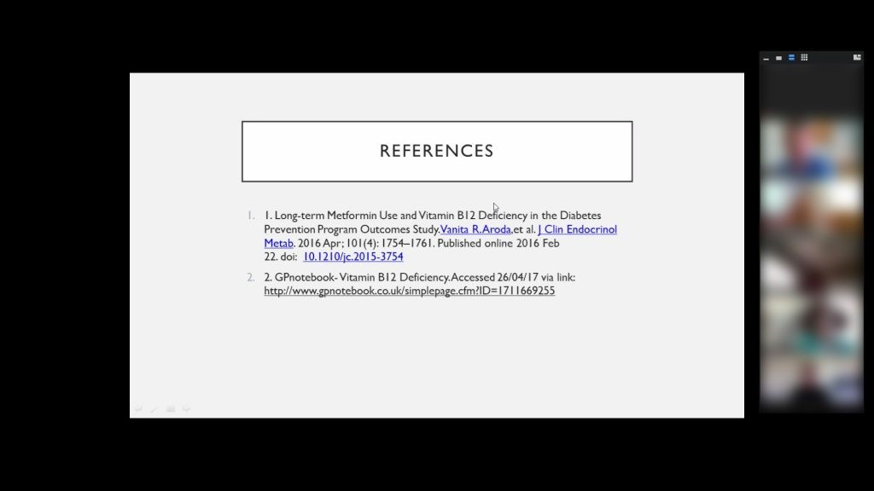
Zoom – Screen share

A FEW OTHER TIPS
- Share any PowerPoints using Reader View. This keeps the taskbar at the bottom open to make navigation easier
- Consider joining the meeting from your own mobile phone in addition to a PC. This provides the teacher with the student view if sharing screen, etc

