Here, we have a look at how to set up a meeting.
- In your account, click Meetings.
- Click Schedule a New Meeting.
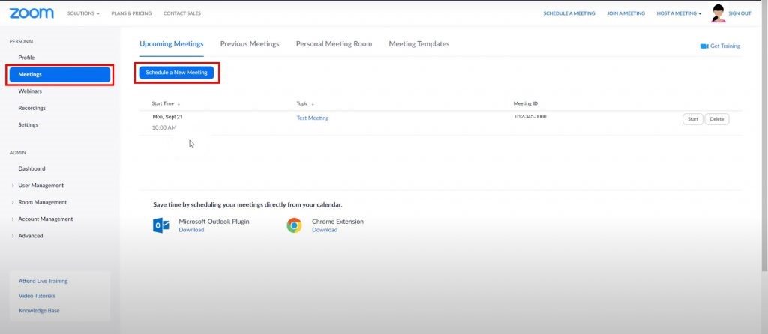

Zoom – scheduling a meeting
- Add Topic, Description, set Date and Time.
- Choose Zoom Duration (it’s better to over estimate this) and ensure you’re in the right timezone (BST/GMT).
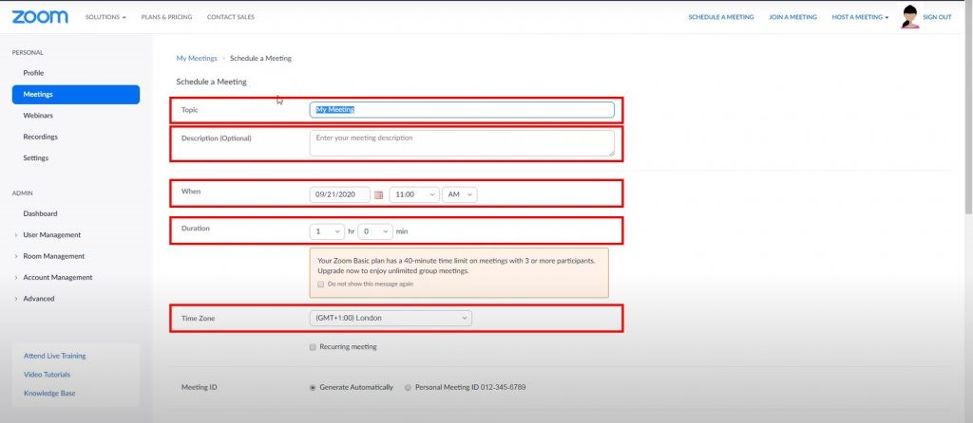

Zoom – meeting details
- Once you have all the details set, scroll down the page and click Save.
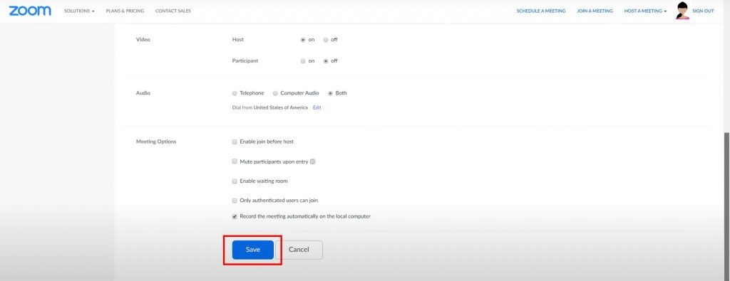

Next, let’s look at Meeting Settings.

- If you are the host, have your video set as ON and the participants set as OFF. If participants are on, it slows down the quality of the zoom. Participants videos can be turned on later.
- For Audio, choose both. Most people will be using tablets or machines rather than telephones. Using BOTH covers all devices and a number of students may be using their phones.

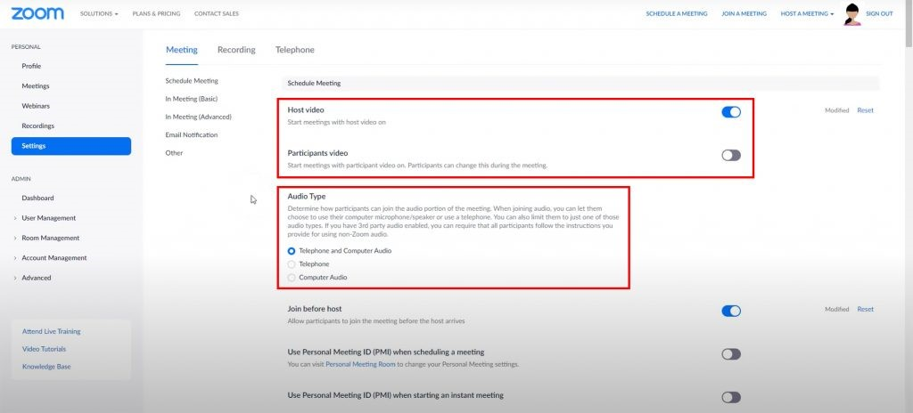

Zoom – settings options
- In the Meetings options, it’s helpful to Mute Participants on Entry, so only one person can talk at a time.

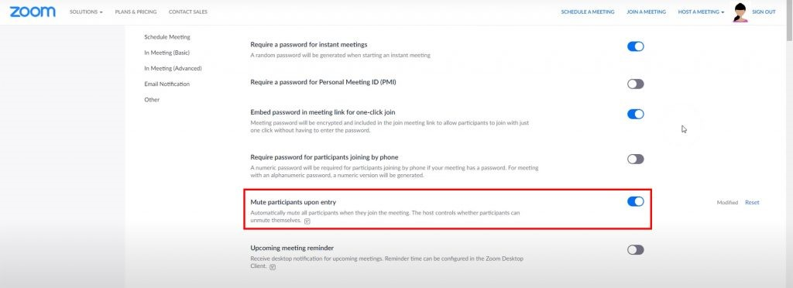

After scheduling a meeting, a link to join the meeting can be shared.
Zoom creates a really simple invite on the right hand side.
This is a quick copy and paste to relevant email
You only need the first couple of lines down to the link.

Hosting a meeting
As a teacher, it’s important you enter the meeting before students.
Meetings can and should be set up to hold participants ‘in the waiting room’ until the host is ready to let them in. This gives you (as a teacher) time to open teaching content, videos, activities, etc., and prep them for the online session. Always take time to set up your teaching.

- Open the chat window, add a message for participants entering the room.
This might, for example, say teaching will last 40 minutes with a Q&A session.
- Click on Participants to see who is joining the room.
- If someone needs invited in real-time, click the circle icon top left to show the current meeting details.
Copy and paste the link to an email and invite any missed persons.
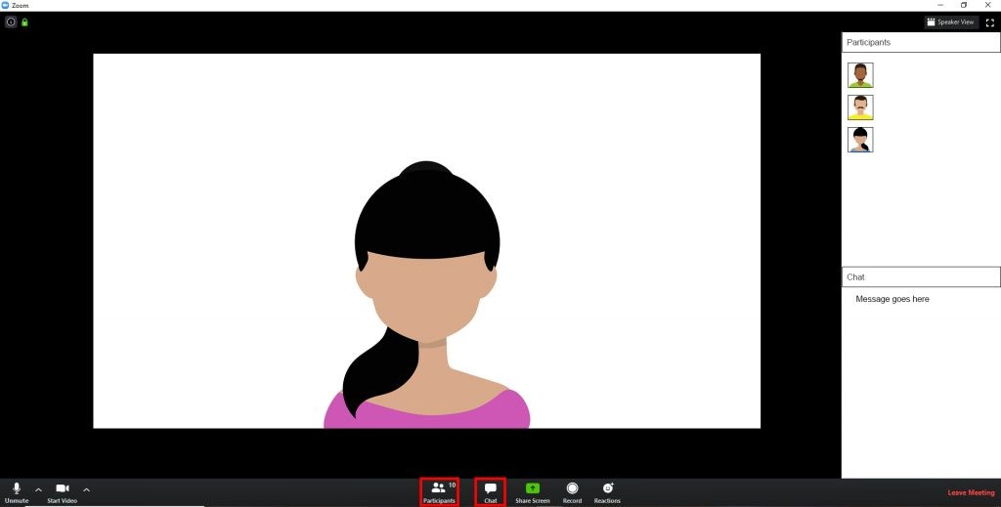

- Working with audio – mute all participants before entry to the room.
Realistically, participants should ‘raise their hand’ which indicates they have a question and you can unmute everyone or individual participants. Students cannot all talk at the same time.
- When muting students, students receive the message on screen “You are muted. Press Alt+A to unmute your microphone or press and hold the SPACE key to temporarily unmute”.

Students joining a meeting
Let’s have a look at how students would join the meeting.
- From an email invite, click the Zoom link.
For Zoom to run, it needs a plug-in downloaded to the computer. Once downloaded, you can Open Zoom. Otherwise Zoom will automatically open in a window to check sound.
- Click Test the Sound and Microphone.
In Speakers, if you hear the ‘ringtone’, click Yes. Then change the drop-down to Microphone. Test this and if happy the microphone works, click Yes.
After setting the sound, click Join with Computer Audio. This button activates your machine for hearing and speaking in the meeting.
- Click Join with Computer Audio on the next dialogue box.

Participants in the meeting
- Don’t assume what you see as a teacher is what students see, it’s not.
- Students NEED to open their chat window and the participants (it’s NOT automatic).

