## 



Family Medicine

|  |  |
| --- | --- |
|  | A course for first and second year medical students  Year 1: The Family Attachment Scheme  Year 2: General Practice Experience  Tutor Guide 2023-24  [https://www.med.qub.ac.uk/wp-gp/](https://eur02.safelinks.protection.outlook.com/?url=https%3A%2F%2Fwww.med.qub.ac.uk%2Fwp-gp%2F&data=04%7C01%7CG.Kearney%40qub.ac.uk%7C41b334dcbaab4cffb79b08d9692fe5ef%7Ceaab77eab4a549e3a1e8d6dd23a1f286%7C0%7C0%7C637656476814922113%7CUnknown%7CTWFpbGZsb3d8eyJWIjoiMC4wLjAwMDAiLCJQIjoiV2luMzIiLCJBTiI6Ik1haWwiLCJXVCI6Mn0%3D%7C1000&sdata=gHO%2BCnB9UE4tTdIitm0WnJ7fJP%2FOAHi9vWFFS56yeS8%3D&reserved=0)  Revised August 2023 G Kearney |

**Contents Page**

Introduction 2-3

Attendance 3

**A Guide to the Individual Tutorials Year 1** 4

Session 1 4-6

Session 2 7-8

Session 3 9-10

Session 4 11-12

Session 5 13-14

Marking of Reports 15-18

**A Guide to the Individual Tutorials Year 2** 19

Session 1 20-21

Sessions 2-4 22

Session 5 23

Marking 24

**Appendices**

1 Accessing the Medical Education Portal 25

2 Teaching Plans 26-29

# Introduction

Thank you for being a GP tutor on the Family Medicine course, especially in these continuing uncertain times. The course runs for the first two years of the undergraduate curriculum and comprises of the “Family Attachment Scheme” (FAS) in first year and the “General Practice Experience” (GPE) course in second year. Where possible we endeavour to assign second year students to the practice they attended in first year. This Tutor Guide covers both the FIRST and SECOND years of the course. Even though you may only be taking first or second year students, it may be useful for you to see what the other part of the course entails.

**Student and Tutor feedback at the end of the academic year 22/23 overwhelmingly supported full return to a face to face module, as before. This was realised in 22/23 for Year 1 but the very large cohort of students in Year 2 in 22/23 meant that many GP tutors had to adopt a hybrid approach. I am delighted that the number of students in each year group has returned to normal and so this module reverts fully back to face to face. The priority remains to deliver an experience-based module that it feasible alongside the very demanding clinical environment GPs find themselves in at present. I am therefore happy to speak to any GP tutor about how to make this work in practice.**

## Connected Primary Care Placements

Family Medicine is the first involvement students will have in their Connected Primary Care Placements as a medical student. As part of a deliberate expansion of time medical students spend learning in Primary Care, we are delighted to say that they will now enjoy Primary Care Placement in all five years of medical school. Evidence has shown that increased time spent in Primary Care increases students’ interest in being GPs in the future <https://www.medschools.ac.uk/media/2881/by-choice-not-by-chance.pdf>.

We have based the Primary Care Curriculum on a UK-wide model from the Royal College of General Practitioners called “Teaching General Practice” <https://www.rcgp.org.uk/getmedia/bd108a4b-50ce-42f0-9de4-c3083a2c8586/teaching-general-practice.pdf>.

This link is to the related digital textbook aimed at medical students called “Learning General Practice” <https://www.rcgp.org.uk/getmedia/074af536-aaae-4eef-95cb-63ee18e96fda/learning-general-practice.pdf>

Under the themes of Person-centred care, Population-centred care and Efficient delivery of care in community settings, we have divided out this curriculum to allow different emphasis in each year, building on what has been learnt previously.

The relevant theme of learning in Year 1 and Year 2 are as follows:-

Develop the Foundations of practice to develop and apply knowledge and understanding around:

Year 1 Family Medicine: *Care for the person and care within families*

* Holistic care (the biopsychosocial model)
* Social determinants of health
* Medical ethics
* Foundations of Scholarly General Practice

Year 2 Family Medicine: *Care within the GP Practice and care within communities*

* Holistic care (the biopsychosocial model)
* The doctor-patient relationship
* Information Technology
* Teamwork and leadership
* History of UK general practice
* Current structure of UK general practice
* Funding of UK general practice
* Role of general practice in other countries

In the first year of the FAS, the five tutorials will take place in the practice. Patients/families who would be happy to have two-three students in their homes should be chosen for contact. As in previous years, you will need to ensure that the patients/families are available on the date of the second session to meet their students. In the second year GPE component, five tutorials will take place in the practice. The emphasis will be on patient contact and on meeting the Primary Care Team. New guidance on ‘home visits’ by medical students for students, patients and GP tutors is available on the tutor website.

I have said before that research carried out in the past suggested that your patients are very enthusiastic about the scheme and enjoy the students’ company. Additionally, the FAS receives enthusiastic feedback from the students and received particular mention during the GMC visit in 2017. This brief guide is designed to give you a relatively quick overview and aide memoire for the composition of the first and second year components.

## Attendance

Students are expected to attend 100% of tutorials – they are made aware of this. If they are going to miss a tutorial for any reason, they are required to lodge a certificate in CME and to let you know as their tutor. Repeating students who have previously passed this module are still expected to fully attend tutorials and patient contacts; these students are not however expected to contribute to a new report in first year or the end of course assessment presentation in second year. You will be specifically told if any of your cohort are repeating. I suggest for first year, adding a repeating student to an existing pair may work best in case there are any attendance issues.

A Guide to the Individual Tutorials Year 1

# Year 1 The Family Attachment Scheme

## Preparing for the students

I am delighted that we continue with a normal Family Attachment scheme with student group size back to normal. This tutor guide is written for a fully face to face module, I am happy to discuss with anyone who might choose to do some of these remotely. I am once again asking you to find patients/families who are willing to have a small group of students in their home for early clinical contact. You may find it useful to discuss with your colleagues which patients you could approach to take part in the scheme. It would be ideal if you could arrange with these patients before the first tutorial but as always, there will also be time to make these arrangements between the first and second tutorials. Generally the students are slit into groups of two or three for each patient/family. Make sure you have a room available for your first tutorial, have read through the guideline material and have thought through how you will deliver the tutorial.

After the success of the introduction of “Cultural Humility”, we will be continuing this in 23/24. It essentially involves “becoming the student of the patient”. I will teach the students about this in their introduction to Family Attachment and this will be supported by a video and some links for further reading. I hope you will again touch on it in the first tutorial and revisit in the fifth, as they will need to reflect on it in their personal reflective blogs. It is not necessary for students or tutors to have a sophisticated understanding of this concept, however as you read a little about it under sessions one and five below, I hope you will recognise it as the ethos of the course and how you teach it (without previously knowing it under this name).

# Family Attachment Session 1- Introduction to the Family Attachment Scheme

This first session will allow students to get to know each other and you to get to know the group. You can explain to them about the practice and could offer them a tour. The object is to get students thinking about communication which forms a key part of what the Family Attachment Scheme is about. The session will thus be an important contributor to this semester's workshops on Clinical Communication with which there will be some overlap.

## Learning outcomes for this session are:

* Be able to discuss why clinical communication is so important
* Begin to understand the characteristics of satisfactory and unsatisfactory communication
* Gain an understanding of the Aims and Objectives of the Family Attachment Scheme
* Consider how to “become the student of the patient” using Cultural Humility

## Preparation:

Students will be asked to become familiar with "[Duties of a doctor](http://www.gmc-uk.org/guidance/good_medical_practice/duties_of_a_doctor.asp)". Students should be prepared to discuss this in your tutorial group. They have also been asked to be familiar with the Cultural Humility resources.

## Tutorial suggested activities:

* Introductions to the students, GP tutor and the practice
* Overview of the Family Attachment Scheme. There are two short videos available on the portal, under “Tutor’s resources” and on the tutor website to use if you wish. ([https://www.med.qub.ac.uk/wp-gp/](https://eur02.safelinks.protection.outlook.com/?url=https%3A%2F%2Fwww.med.qub.ac.uk%2Fwp-gp%2F&data=04%7C01%7CG.Kearney%40qub.ac.uk%7C41b334dcbaab4cffb79b08d9692fe5ef%7Ceaab77eab4a549e3a1e8d6dd23a1f286%7C0%7C0%7C637656476814922113%7CUnknown%7CTWFpbGZsb3d8eyJWIjoiMC4wLjAwMDAiLCJQIjoiV2luMzIiLCJBTiI6Ik1haWwiLCJXVCI6Mn0%3D%7C1000&sdata=gHO%2BCnB9UE4tTdIitm0WnJ7fJP%2FOAHi9vWFFS56yeS8%3D&reserved=0)). One is previous year’s students discussing their learning experience in Family Attachment and one is some tips on early clinical contact by myself.
* Group discussion about the "Duties of a doctor" and how this relates to communication
* Exercise – How do I become the “student of the patient?” Consider Cultural Humility and how it relates to the Family Attachment scheme

## Cultural Humility

The concept of Cultural Humility is an important anchor in Family Attachment. It involves active development of consciousness of the uniqueness of every patient, in order to foster mutually respectful partnerships with patients and wider communities. It begins with an understanding of our own culture, cultural assumptions, and health beliefs, what we bring to patient encounters, which helps us reflect on the belief systems of others (patients). It encourages students to think democratically about what patients bring to clinical encounters and put simply, embracing how they “become the student of the patient”. It involves awareness of power differentials between groups; within the culture of medicine, this includes between patients and doctors and the need to address this.

Cultural Humility aligns with a commitment to the increasing emphasis on Equality, Diversity, and Inclusion. In other parts of the curriculum, students will learn about cultural awareness, knowledge, and skills. In Family Attachment, students have the opportunity to weave these into patient encounters; to put Cultural Humility into practice.

I will have addressed Cultural Humility with the students in their introductory lecture. In addition, we have made a video on it and how it relates to the Family Attachment scheme. The link to this video and other relevant links will be placed on the portal and tutor website in case you are keen to learn a little more about it. It is not intended that much of this important first tutorial is spent on this, nor that you should be ‘teaching it’ as such. The concept is likely to be difficult to grasp and you can reassure the students of this. However, as the students spend the next few months learning from their patient and finding this a valuable experience, they should feel ready to discuss this in the final tutorial and in preparation for their personal blogs. There will be further reading around this on the portal for the students, so feel free to direct them there with any questions they have. Whilst the title Cultural Humility might be new to you, as it was to me, I hope you will recognise it as aligning with the ethos of Family Attachment and indeed much of the students’ learning around it will be from how you model it in how you talk about your interactions and experiences with patients.

The below table of the 5Rs of Cultural Humility is what will suggest they use to reflect on it in their blogs. You can use it here in Session 1 if you want. You will be using it in Session 5 when they are planning their blogs.



Reference - The 5 Rs of Cultural Humility: A Conceptual Model for Health Care Leaders (2020) Robinson, Dea et al. The American Journal of Medicine, Volume 134, Issue 2, 161 - 163 **DOI:** [**https://doi.org/10.1016/j.amjmed.2020.09.029**](https://doi.org/10.1016/j.amjmed.2020.09.029)

Some tutors have requested more resource on Cultural Humility. I don’t want to overwhelm any tutors with material, but this 2.5 minute video below is a succinct introduction.

<https://www.youtube.com/watch?v=c_wOnJJEfxE>

Tutors can use as much or as little of this suggested material as they want on the day. At the end of this first tutorial, you will need to explain to the students how they are going to meet their patients during the second tutorial, and how you wish to run that. Prompt them to watch the video “Preparing for Early Clinical Contact” in advance of the next session if you haven’t watched it together in this Session.

# Family Attachment Session 2 - Contacting the families

Most of the time allocated to this tutorial will be taken up introducing your students in their groups to the families. The students have been prompted to watch **the video by** entitled “Preparing for Early Clinical Contact” which gives some useful advice about how to approach that first patient contact and about communication in general. **It is fine to watch this short video together in the tutorial.**

## ****Learning outcomes for this session are:****

* Understand the importance of listening when consulting with patients
* Plan how you will approach contacting your patient within your smaller groups
* Begin to develop an awareness of your own communication styles and techniques
* Understand the importance of working effectively as a team

## ****Preparation:****

Students are asked to look at the video on “Preparing for Early Clinical Contact” in advance.

## ****Tutorial activities:****

* Group discussion about the first patient contact, can watch the short video live together. Students have the opportunity to ask any questions before they make contact.
* Talk students through completing a consent form to allow access the person's confidential medical files at a later stage. Students can plan to bring this with them during their visit. It is however the student’s responsibility to have this conversation with the patient.
* Contact with patients – it is suggested that after half an hour or an hour, you will introduce your pairs/trios of students to their patients/families. How you do this is up to you. Some tutors physically accompany the students to the patient’s door, some give them directions and some again arrange for the patients/families to come down to the practice for this first contact. After this, students should spend some time chatting to the patients themselves. They should arrange with their patient a mutually convenient time for them to return for a follow up visit. **They should visit on two-three occasions, outside their tutorials.**
* After the patient contact – where possible, you can convene the student group after their first contact. In the discussion, students should concentrate on how they felt they communicated with the patient and how they are feeling about future contact. They can use the remaining time of the session in their pairs/trios to plan how their next contact.

Students should be reminded to make a reflective diary entry immediately after the session - record what was discussed and their thoughts and feelings about the patient and their experience. Such reflections can also be included in their Reflective Practice Portfolio. Students should be prepared to make a brief presentation[1] in pairs of what they have learned about their patients/families at the next session.

# Family Attachment Session 3 -Review of the first contact, planning next contact and considering communication skills

This tutorial will focus on how students got on during their first contact (s) with their patient. They should be given an opportunity to discuss their experiences to date, to learn about their colleagues' experiences in their contacts and to reflect on what they have learnt about clinical communication so far. Students can discuss how have developed the interviews with their patients, examining difficulties they may have in common and exploring solutions to any communication problems. They can then be supported to consider how to further their communication with their patients. They will also concentrate on concerns that patients have raised, throughout their contact.

**Learning outcomes for this session are:**

* Consider how and why patients discuss health concerns
* Be able to discuss where clinical communication happens in Primary Care
* Be able to discuss the differences in how illness is perceived by different stakeholders (e.g.: patient; family; GP; Consultant)
* Understand how these stakeholders work together, and how they communicate with each other
* Understand potential points where communication can break down, and the consequences of this
* Demonstrate an ability to further develop themes and lines of enquiry when conducting follow up visits with patients
* Describe strategies for coping with any difficulties in communication encountered.

**Preparation:**

Each pair of students should be instructed to discuss their first encounter(s) with their patient and have completed a diary entry. **Remember that such a diary entry could potentially form an excellent contribution to their first year portfolio.** Pairs of students should present a five-minute presentation of what they learned about their patients/families.

**Tutorial activities:**

* Each pair of students should make a brief (5-minute) presentation about what they have learned about their patient/family. A group discussion will be held after each presentation to help highlight the salient learning points. Students are encouraged to **reflect on what they felt was easy and what they felt to be more difficult about the process**
* Each pair of students will be asked to consider how they might conduct the next patient interview. This will be aided by contributions from the tutor and tutorial group. This is to **include obtaining permission to examine the clinical notes**.
* Discussion on challenges in the communication and concerns the patient has that have emerged in interviews

**Homework:**

Discuss with the group and give each pair of students a topic to research that is relevant to looking after patients in the community. They should be instructed **in pairs/trios** to prepare a short 5-10 minute presentation[2] on the topic for delivery and discussion at the next tutorial. This does not have to be exhaustive! They should be told that they can decide which aspect(s) of the topic they wish to explore but to try to use their reflections on their patient contact so far to illustrate it. Examples of topics are:

|  |  |
| --- | --- |
| * Living with disability or chronic illness * Advocacy in Primary Care | * Ethical issues in Primary Care * Holistic Care in Primary Care |

## Family Attachment Session 4 – Special presentations, introduction to medical notes and starting to put together the report

This penultimate tutorial will focus on helping students identify the most relevant and interesting aspects of their Family Attachment study to include in the final report. They should be encouraged to reflect on and interpret the observations they have made during their contacts.

Students will also have the opportunity to practise presentation skills by delivering a short talk on the special topic they were given as homework at the previous tutorial. Together these activities will broaden perspectives with regard to writing up the Family Attachment Report. Tutors can bring together these presentations to help the group reflect on the role that GPs and Primary Care teams play in patients’ lives and the vital role of communication in healthcare.

During this tutorial please give the students an introduction to medical notes and an opportunity to inspect their patients' clinical records, which may add another dimension to their understanding of the patient. Please reiterate the need for confidentiality in this privileged activity and press on them the importance of not including any identifying features on any notes they make. They should have ensured that that they have consent from their patients to look at their clinical notes.

## Learning outcomes for this session are:

* Be able to research, create and deliver a presentation on a specialist topic
* Consider the role Primary Care teams play in the lives of patients
* Introduction to GP clinical records and the importance of keeping good clinical notes
* Discover how clinical records are structured and the information they do and do not contain
* Students to have the opportunity to inspect their patients' clinical record over this tutorial
* Synthesise information from clinical notes and patient encounters

## Preparation - before students arrive at the tutorial:

Students should have prepared the special topic presentation from last semester. They should have ensured that that they have consent from their patients to look at their clinical notes.

## Tutorial activities:

* Each pair of students should make a brief (5 -10 minute) presentation on their special topic
* Discussion on the role that Primary Care teams play in the lives of patients
* Discussion on the diversity of professional communications as this traverses everything that happens during clinical contact
* Introduction to medical notes by the GP tutor
* Brief (30 minute) scrutiny of patient notes (to be presented at the final tutorial)
* Each pair of students will be asked to consider what they have learned from the notes compared to what they had learned from the patients

## Homework:

Students should prepare a 5-minute presentation[3] outlining the salient points and insights they are going to discuss in their Family Attachment report. Where they have had the chance, students should discuss in their pairs what they learned from inspection of the patient notes and to compare and contrast what they have learned from the notes and from the patient and include this in the presentation.

# Family Attachment Session 5 – Creating the Family Attachment report and reflective blog

This tutorial will be an opportunity to tie up loose ends and to discuss the main issues concerning the patients. The starting point could be the students’ commentaries on what they discovered when examining the clinical records compared to their own discovered knowledge of the patient. If possible, they should have made final contact with their patients before this tutorial and reviewed their diary entries. The students should discuss how following their “real, unique, live” case is similar/different to the cases in CBL. In this session, you will revisit the concept of Cultural Humility and reflect on what students have learned, as ‘the student of the patient’, in preparation for their blogs. This will then allow a final opportunity to discuss any questions they may have.

The emphasis should be on attempting to derive meaning and to interpret the observations they have made about their patients. Reports should now be in an advanced stage of preparation, and they should be able to discuss them during the tutorial. This will allow students to learn from each other and to draw comparisons between patients in each of their reports.

## Learning outcomes for this session are:

* Propose how the group plans to structure their report
* Be able to discuss the main points of interest in their Family Attachment report
* Be able to compare and contrast the contents of the clinical record with their own knowledge of the patient
* Be able to compare their “real live” case with the cases encountered in CBL
* Discussion about the features of a good Family Attachment report
* Be able to work as a team in the production of a report
* Revisit Cultural Humility in preparation for the students’ personal blog

## Preparation:

Students are asked to discuss in detail with their partners how their knowledge of the patient(s) contrasts / agrees with what they have discerned from their brief inspection of the notes.

Students should have reviewed their diary entries and have started to flesh out their reports. They have been asked to consider in advance what they have learned about their own culture and cultural assumptions. These could be as simple as the expectation that family members may act as carers for each other or the expectation of getting a GP appointment when you need one. They should think about how following this “real, unique, Live” case is similar/different to the cases in CBL.

Students should put together a presentation outlining how they will approach writing their reports. Remind students that they cannot put everything in the report. They need to be discriminating picking out important insights they have gained and what they think would be of interest to a reader.

## Tutorial activities:

* Each pair/trio of students should make a presentation on how they propose to structure their report. This will allow group discussion and the generation of ideas about how each report could be potentially improved.
* Students to discuss the main points of interest in their Family Attachment Report.
* Students to describe how they compared and contrasted the contents of the clinical record their knowledge of the patient
* Students compare their “real live” case with the cases they encountered in CBL
* Discussion about the features of a good Family Attachment report.
* In preparation for writing their personal blog, revisit cultural humility **– “What you have learned as the student of the patient?”** Broadly, you can discuss what they have learned about their personal cultural assumptions and health beliefs, for example from within their extended families, society, social networks. How are they similar/different to their patients remembering that culture is broader than ethnicity (includes gender, sexuality, socio-economic background)? Students can use the 5Rs table below to structure their blog if they want. Tutors can use this also to structure these discussions.



Reference - The 5 Rs of Cultural Humility: A Conceptual Model for Health Care Leaders (2020) Robinson, Dea et al. The American Journal of Medicine, Volume 134, Issue 2, 161 - 163 **DOI:** [**https://doi.org/10.1016/j.amjmed.2020.09.029**](https://doi.org/10.1016/j.amjmed.2020.09.029)

Student will also include more general reflections on the Family Attachment scheme in their blog as they did before – what they got out of the experience, how their found interviewing etc. They have detail on this in their study guide.

## Marking of Reports

Tutors are asked to mark the reports of their own group. Students have been told to send the report both directly to you and to the gpadmin email address. There will usually be one report between two or three students. Each student has to sign a declaration at the front of the report that they have contributed equally to the work involved. In addition, we ask each student to write a separate 500 word personal reflective blog to be included as Appendix to the report. You are asked to mark the overall report for which all students receive the same mark. You are also asked to award individual marks for the personal reflective blog. Therefore, students may get different marks for the same report. Towards the end of the course, you will receive an email link to an MS form to be filled in for each student as their marking sheet.

An example of the MS form is given over the next fer pages. Penalties for going over the word count have been removed. The maximum score for the joint report is 25 and 5 for the personal blog. There is space to give students feedback on their reports and on their personal blogs. It is perfectly acceptable that feedback for the overall report be the same for all the students within the group with only their blog feedback differing. Remember, if you get the same set of students again in second year, they might like to revisit this feedback.

# Screenshot of MS form for marking

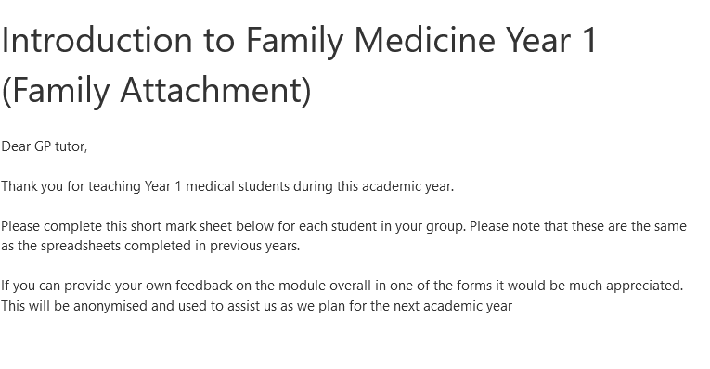

## 

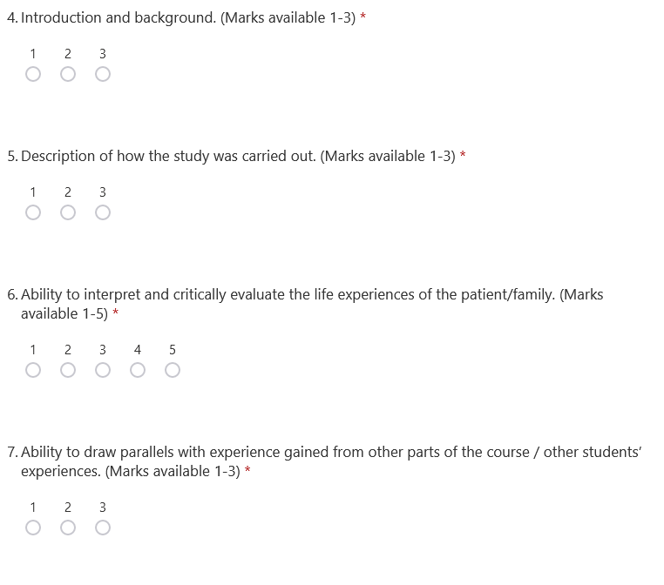

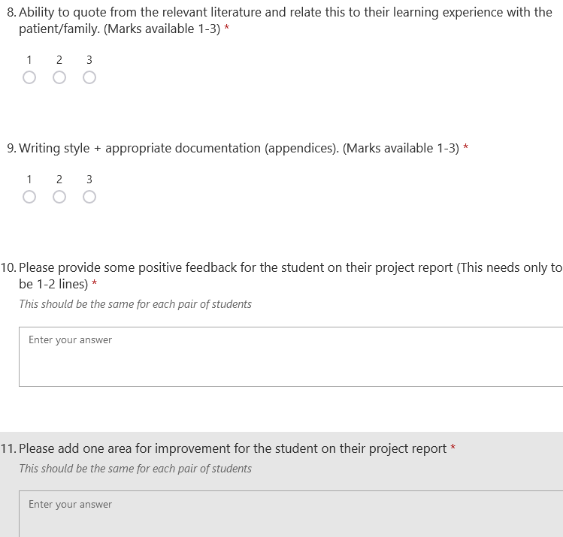

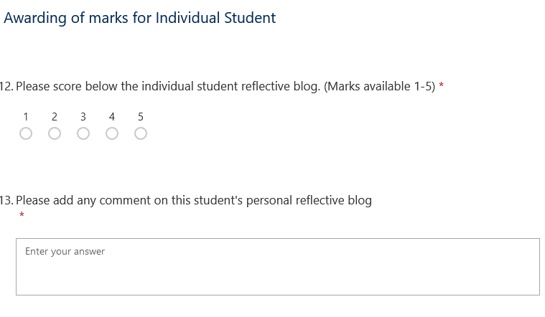

A Guide to the Individual Tutorials Year 2

# Year 2 General Practice Experience

In second year, students will build on their experience of the Family Attachment Scheme with more focus on how General Practice delivers care to patients. In the Family Attachment component in first year, students will have been afforded important insights into how patients see their health and health care. In the second year, we will concentrate on how Primary Care is delivered to patients and how patient’s needs are addressed in the community.

## Preparing to receive students

I am delighted that Year 2 Family Medicine will be returning to a fully face to face module for 23/24. This is based on feedback from both students and GP tutors, and a return to normal intake of students. The structure of the Sessions will revert to one similar to pre-2020. Session 1 with be an Introduction to General Practice and to the module General Practice Experience. Session 2-4 will involve practice-based activities with a focus on learning from patients and members of the Primary Care team. Session 5 will be their assessment. The presentations designed for use in the remote and hybrid modules have been incorporated into the first session, to allow the focus in Session 2-4 to on people rather than PowerPoints! In the “Teaching General Practice” framework I described in the introduction to this tutor guide, Year 2 Family Medicine is a natural home to realise the following aspiration, “*We strongly recommend students being encouraged to consult with patients one-to-one from an early stage in training*.”

It has been drawn to the students’ attention that students in different practices will have different experiences in this module. In addition, they are aware that the plan for their teaching might change if the clinical situation was to change. Some preparation in advance will be required to make best use of the time in Session 2-4, especially when involving members of the MDT and patients.

In addition to involving other members of the Primary Care with the students, you could consider involving some more senior medical students or trainees, as something that might spread the burden and be of mutual benefit.

# Session 1 Introduction to General Practice Experience

This introductory session will be a practice tutorial, using a PowerPoint presentation led by yourself to allow some insight into what happens in the world of Primary Care and the multiplicity of roles that make up a day in General Practice.

## Learning outcomes for this session are:

* To understand General Practice and how it meets patient’s needs
* To outline what distinguishes General Practice and Primary Care from hospital medicine and Secondary Care
* To develop a person-centred mindset by considering “the work of being a patient”
* To learn how General Practice developed in the UK

The session will be in two parts.

The first part will be the traditional talk on **“The Essence of General Practice”,** offering insights into the ethos and principles of General Practice including first point of contact, early undifferentiated illness, dealing with chronic disease, anticipatory care, registered patient population, continuity of care, the importance of good consultation skills etc. I have included some slides on the MDT and different modes of consultations, which were previously the focus of teaching in different Sessions. For anyone keen to do these in more details in Sessions 2-4, I have kept the Teaching Plans in Appendix 2 of this guide.

Some tutors may have their first year group from the previous year again, but for many students, your practice will be new to them. Tell them about yourself and your practice. Student feedback suggest that they enjoy hearing the variety of routes tutors have taken into General Practice, so I have included a slide to prompt you to talk a little about this. You can explain to them what will be expected of them in their final Session, as their assessment for the module. They will present on the below brief, individually, in pairs or trios, at your discretion.

The brief for the presentation is : **“Using your experience in General Practice (both with patients and staff), how has General Practice evolved to provide person-centred care, population centred care and efficient delivery of care in community settings? Illustrate with examples from your time in General Practice Experience.”**

The second part of the tutorial builds on the tutorial previously delivered as the “work of the patient”. At the end of the PowerPoint, there are some preliminary interactive exercises to get them thinking with some notes for tutors, asking students to discuss and put into a timeline what they think a patient ‘does’ when they decide they need to see a GP. They might need some help getting started and jump to ‘phone the practice’, try to bring them back even to the point where they decide to seek help. The students as health literate, IT savvy, confident young people may see little problems with this. In the notes of the PowerPoint are a number of points you can use to challenge them on this e.g. what if they are a carer, what if they are agoraphobic. The idea is to help the students consider, using this as an example of something simple and seemingly routine like seeking an appointment, of some of the work that a patient does to manage their health and illness and to negotiate having their needs met in Primary Care. **Please arrange to have a patient attend at this point of the Session (perhaps an hour in), who is happy to talk about what they have to do to manage their health in their experience and expertise.** Listening to this patient will help the students reflect on what is involved in patienthood, within a person centred mindset.

Obviously, you will want the patient to lead this discussion but what you really want them to concentrate on is how they manage living with their illness. I suggest starting with asking then a little about how and when they were diagnosed, just for context. Then ask about a typical day for them – what you really want is how they live with their illness as opposed to clinical details that students can get from a textbook. This may need teased out a little as the patients are also probably not used to discussing this ‘hidden work’ in detail or having anyone listen to them about it for any length of time! For example, if they say “I check my blood sugars twice a day” ask then to describe step by step what this actually means – when do they do it, where, how they do it, how does it feel and what they do with the result. Could they demonstrate it for the students? What you want is the behind the scenes information that doesn’t get written down anywhere and that students won’t learn about or appreciate otherwise.

# Sessions 2-4 – Practice-based activities

These three Sessions provide the opportunities for the focus of the module, to learn about care within the practice and the community from both patients and practice staff. Feedback from students and GP tutors indicate that the most important thing in this module is patient contact. It is hoped that within these three Sessions the students get a number of opportunities for this. I suggest dividing the students into two or three groups depending on numbers. Whilst one subgroup is meeting a patient/patients, the other students can be rotating through a number of other practice-based activities which will be dictated by what is happening on that afternoon and who is present, in a working practice.

In the box below are a number of suggestions for what students could be doing in sub groups, whilst you are supervising students consulting with patients.

Possible activities

* Observing members of the MDT, either clinical staff e.g. Practice Nurse, Treatment room Nurse, Practice Pharmacist or managerial/admin staff e.g. receptionist, Practice Manager
* Spending time observing the overall functioning of a patient e.g. in the Waiting Room
* Visit Family Attachment patients/families (if attached to the same practice)

**Patient consultations**

In these Sessions, students will for the first time get to see how GPs consult in practice. Where possible, you may facilitate students to take part in a consultation, as part of a small group of students, under your supervision, either directly or indirectly. Patients will either have been chosen specially to come down to meet the students as ‘expert patients’ or they may be patients who have recently contacted the practice with a health need. You will need to consent them in advance that students will be present and taking part in their consultation. This opportunity to witness consultations aligns both with “becoming the student of the patient” from Cultural Humility and with developing a person-centred mindset.

# Sessions 5 – Assessment

This final session will constitute the Assessment for General Practice Experience.

## Assessment

Although you will have been assessing the students on a continuous basis, a specific assessment session will allow an opportunity for individual assessment and feedback. As part of the formal assessment, each student pair or trio, at your discretion, will deliver a 5-10-minute PowerPoint presentation drawing on their experience in the module.

As part of the continuous assessment, please assess the students on the following two parameters:

* Individual Contribution to tutorials
* Quality of end of course presentation

Each component need only be judged as satisfactory or unsatisfactory. You will be asked to provide some brief comments by way of feedback to the students on an MS form. You can decide whether you do this live or take notes and fill in the forms later. An email with link to the forms will be sent in advance of this session.

**Contribution to tutorials**

You should consider **attendance, participation, and engagement** (as per the assessment sheet) to come to a decision about whether each student’s contribution was satisfactory.

**End of course Presentation**

The students have been given the following brief for their presentations.

**“Using your experience in General Practice (both with patients and staff), how has General Practice provide person-centred care, population centred care and efficient delivery of care in community settings? Illustrate with examples from your time in General Practice Experience.”**

You will receive the link for the MS form (on the next page) which is to be filled in for each student. It is recognised that students in pairs may get the same feedback. You can do this ‘live’ during the session or make a few notes and do this later.

# Screenshot of MS form for marking

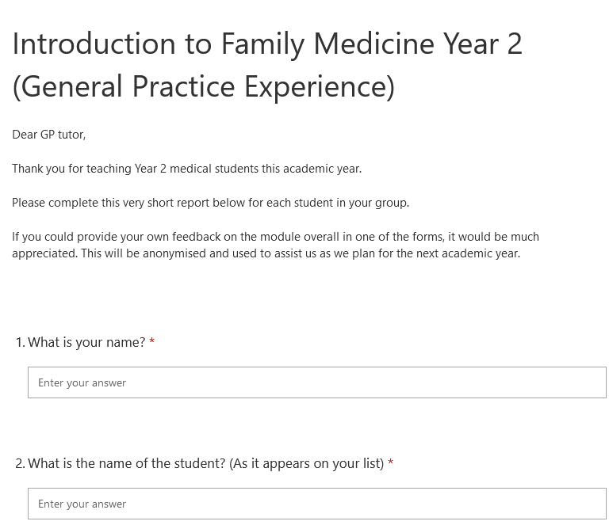

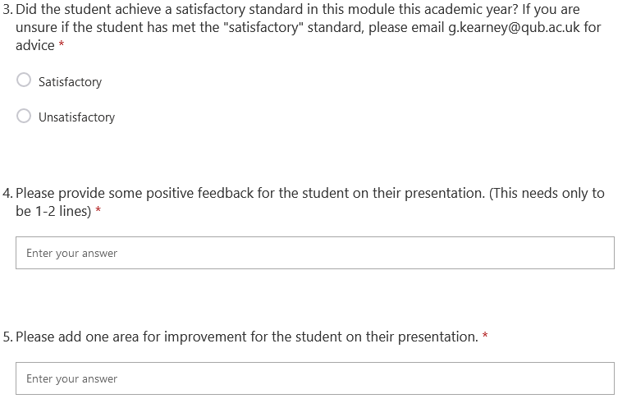

**APPENDIX 1**

# Accessing the medical education online portal

Previously you only needed a generic username and password to access the medical education portal.  
In recent years, the education portal has been through a major overhaul and has many new features. We have also implemented a more robust user authentication system which means that each user will have a unique username and password. Registering for this is simple. Go onto the site at [**https://www.med.qub.ac.uk/portal/**](https://www.med.qub.ac.uk/portal/)and follow the instructions below:

|  |  |
| --- | --- |
|  | Click on “Online Registration” form or “Register”  This will bring you to the registration form below |
|  | Complete the registration form with your own details, select a password before clicking on “register” at the bottom of the form.  Please note the following email address formats are permitted: (name of practice).gp.n-i.nhs.uk (trust name).hscni.net  You may be able to register using another email address. Please  contact Eamon O’Hagan as per instructions on screen. |

**Once the registration form has been submitted an email which includes a confirmation link will be sent to your registered email address. Once you have clicked on this confirmation link you will have access to the portal.**

**APPENDIX 2 (not essential)**

# Teaching Plan - Modes of consultation

## Plan

1 hour session delivered over zoom by GP tutor to their group of students

A framework PowerPoint will be supplied but the intention would be for an interactive discussion, peppered with the experiences of the tutor. Tutor may decide not even to put up the slides but just use as a prompt, to promote interaction, I have included the below prompt for interactive activities.



The slides are deliberately brief, I have included some suggestions in the notes below which tutors are welcome to use or ignore! For the suggested interactive elements, you can decide whether you do this just by students chipping in on their mics, using the chat function or even breakout rooms if you are comfortable with this.

NEW *Tutors and students have asked for increased clinical content in these sessions. For this tutorial, this is most easily achieved by you describing your clinical experiences for example of recent telephone consultations etc. I have included the below prompt for this in the relevant slides*

Additionally, in an attempt to involve patients in each session, it would be great if a patient with experience of different modes could link in to discuss their experiences of and the challenges of these, either in person or over zoom.

## Aim of session

To introduce students to the variety of modes of consultations open to GPs and other clinicians and consider their advantages and pitfalls

## Framework

* Aim of Session
* Background
* Interactive - Where do consultations take place in Primary Care?
* Interactive - Brainstorm the different modes of consultation – F2F, telephone, video, online/text based

Consider each in turn

* F2F
* Telephone (triage v consult)
* Video
* Online/text-based
* Interactive - Advantages
* Interactive - Pitfalls
* Interactive - Who might struggle
* Safety netting
* Interactive - FA over Zoom?
* Revisit Aim

## Possible extension

The below resource on remote consultations and triage might be something that you want to refer students to either during or afterwards

https://elearning.rcgp.org.uk/mod/page/view.php?id=10812

## Tutor tips from tutor feedback and tutor development meeting

* As above, include the GP’s experience and even patient experience where possible, in order to increase clinical content

# Teaching Plan - The Multidisciplinary Team in Primary Care

## Plan

1 hour session delivered over zoom by GP tutor to their group of students

A framework PowerPoint will be supplied but the intention would be for an interactive discussion, peppered with the experiences of the tutor. Tutor may decide not even to put up the slides but just use as a prompt, to promote interaction, I have included the below prompt for interactive activities.



The slides are deliberately brief, I have included some suggestions in the notes below which tutors are welcome to use or ignore! For the suggested interactive elements, you can decide whether you do this just by students chipping in on their mics, using the chat function or even breakout rooms if you are comfortable with this.

This session would be enhanced by some “live” appearances from other members of your Primary Care Team. Think about who the students would meet if they were in your practice for these tutorials – the practice nurse, the pharmacist, the practice manager, the treatment room nurse, the receptionist, perhaps even the physiotherapist and the social worker. Students will benefit from hearing about their roles especially specific examples of patients you have cared for as a team. They could link from anywhere, using the Zoom links that the student has used. I have not included this in the PowerPoint that I have prepared as this will be different practice to practice.

NEW *Tutors and students have asked for increased clinical content in these sessions. For this tutorial, this is most easily achieved by you and the other practitioners describing your clinical experiences, working as a team, referring (anonymously of course) to specific patient interactions. I have included the below prompt for this in the relevant slides*

Additionally, in an attempt to involve patients in each session, it would be great if a patient with experience of the MDT could link in to discuss their experiences, either in person or over zoom.

## Aim of session

To introduce students to the multidisciplinary team in Primary Care and consider how they meet patients’ needs together.

## Framework

* Aim of Session
* Background
* Interactive - where do members of the Primary Care Team work?
* Interactive - Brainstorming the MDT – students can share their experiences of this
* Clinical staff (in the practice)
* Admin/Managerial staff
* The Wider Community Team
* Explore an example where the broader MDT meets the needs of a patient with a chronic health condition e.g. Diabetes
* MDT initiative
* Interactive – the advantages and disadvantages, from the students’ perspective
* Revisit aim

## Possible extension

The below resource on MDTs might be something that you want to refer students to either during or afterwards.

https://www.health-ni.gov.uk/publications/general-practice-multi-disciplinary-teams-general-leaflet

## Tutor tips from tutor feedback and tutor development meeting

* Session works well fully remote due to convenience for MDT
* Scope for broadening who is involved with increased uptake of MDT
* As above, include practitioner’s experience and even patient experience where possible, in order to increase clinical content

1. Students are asked to be prepared for presentations in their third, fourth and fifth tutorials. It is up to you as their tutor how formal you want to make these presentations. One suggestion might be that their presentations on their patients in the third and fifth tutorials can be informal i.e. no PowerPoint but that for the fourth is to be more formal.
2. Students are asked to be prepared for presentations in their third, fourth and fifth tutorials. It is up to you as their tutor how formal you want to make these presentations. One suggestion might be that their presentations on their patients in the third and fifth tutorials can be informal i.e. no PowerPoint but that for the fourth is to be more formal.
3. Students are asked to be prepared for presentations in their third, fourth and fifth tutorials. It is up to you as their tutor how formal you want to make these presentations. One suggestion might be that their presentations on their patients in the third and fifth tutorials can be informal i.e. no PowerPoint but that for the fourth is to be more formal etc.