Connecting to WiFi in GP Practices
GP Practices should all have WiFi available for use but you must register to use it.
Go to: https://www.wifi.service.gov.uk/connect-to-govwifi/
You will see this page:
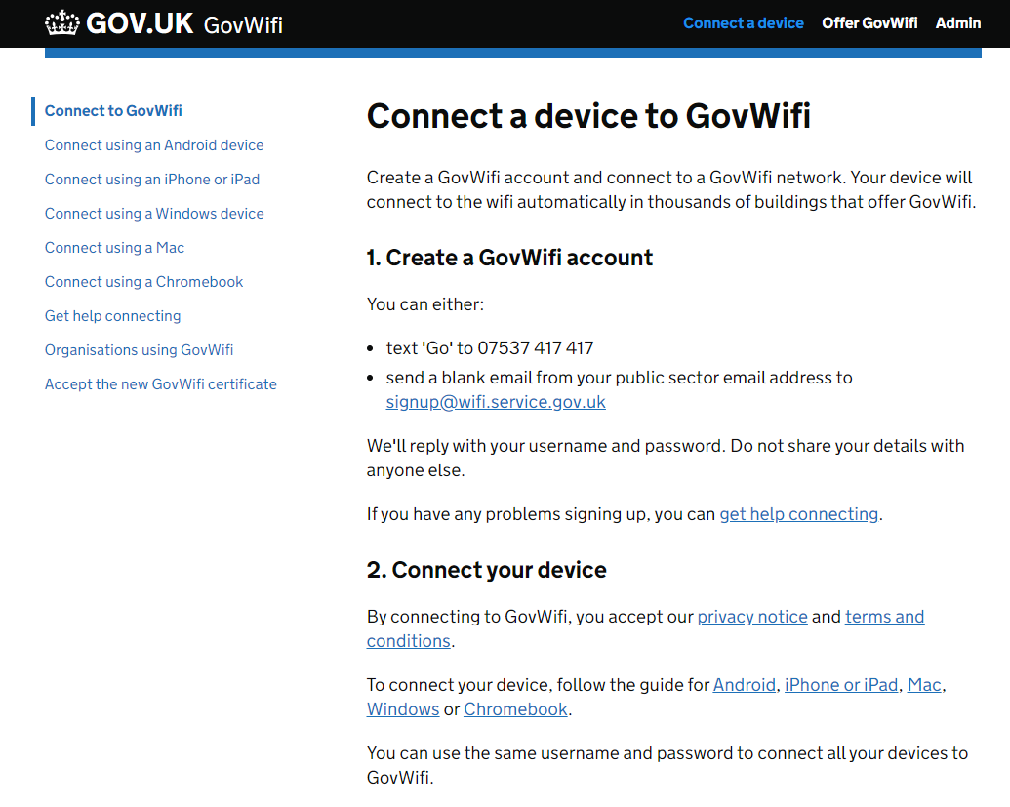
Follow the directions…texting is probably the easiest.
Once registered you simply select GovWiFi from the list of available WiFi connections and log in with the username and password that you have been given at registration.
